EXTRA SUPPLEMENTARY DIGITAL CONTENT
Title: Exposure to air pollution during pregnancy and congenital malformations in Temuco, Chile, a city heavily impacted by wood burning

Authors: Estela Blanco^{1,2}; Carlos Kilchemmann³; José Daniel Conejeros¹⁴; Ismael Bravo^{1,2}; María Elisa Quinteros-Caceres⁵; Salvador Ayala⁶; Ximena Ossa⁷; Maribel Muñoz⁸; Pablo Ruiz-Rudolph⁸

1: College UC y Escuela de Salud Pública, Pontificia Universidad Católica de Chile, Santiago, Chile.
2: Center for Climate and Resilience Research (CR2), Chile.
3: Doctorado en Salud Ambiental y Biomedicina y Escuela de Obstetricia y Puericultura, Universidad Mayor, Chile.
4: ISI Foundation, Turin, Italy.
5: Departamento de Salud Pública. Facultad de Ciencias de la Salud, Universidad de Talca, Talca, Chile.
6: Centro de Epidemiología y Políticas de Salud de la Facultad de Medicina Clínica Alemana, Universidad del Desarrollo, Santiago, Chile.
7: Departamento de Salud Pública y Centro de Excelencia CIGES, Universidad de la Frontera, Temuco, Chile
8: Departamento de Pediatría y Cirugía Infantil, Universidad De La Frontera, Temuco, Chile.
9: Programa de Epidemiología, Instituto de Salud Poblacional, Facultad de Medicina, Universidad de Chile, Santiago, Chile.

Contents of this file
Tables S1 to S2
Figures S1 to S8

Tables:
S1.
Pollutant | Exposure model | Model specifications | AIC | BIC
PM2.5 | Fixed site (cs) | Linear exposure + NS lag (df=4) | 2530.048 | 2660.006
 | Fixed site (cs) | Linear exposure + NS lag (knots 13, 27) | 2529.873 | 2659.831
 | Fixed site (cs) | Quadratic B-spline exposure (df=3) + NS lag (knots 13, 27) | 2466.112 | 2657.226
 | Fixed site (cs) | Cubic B-spline exposure (df=4) + NS lag (knots 13, 27) | 2464.441 | 2686.134
 | Fixed site (cs) | DLM: current week + inverse-distance lag | 2403.152 | 2517.017
 | Land-use regression (sp) | Linear exposure + NS lag (df=4) | 2531.733 | 2661.691
 | Land-use regression (sp) | Linear exposure + NS lag (knots 13, 27) | 2531.589 | 2661.547
 | Land-use regression (sp) | Quadratic B-spline exposure (df=3) + NS lag (knots 13, 27) | 2472.551 | 2663.665
 | Land-use regression (sp) | Cubic B-spline exposure (df=4) + NS lag (knots 13, 27) | 2468.670 | 2690.363
 | Land-use regression (sp) | DLM: current week + inverse-distance lag | 2402.729 | 2516.594
Levoglucosan | Fixed site (cs) | Linear exposure + NS lag (df=4) | 2554.353 | 2684.311
 | Fixed site (cs) | Linear exposure + NS lag (knots 13, 27) | 2554.190 | 2684.148
 | Fixed site (cs) | Quadratic B-spline exposure (df=3) + NS lag (knots 13, 27) | 2500.262 | 2691.376
 | Fixed site (cs) | Cubic B-spline exposure (df=4) + NS lag (knots 13, 27) | 2491.358 | 2713.051
 | Fixed site (cs) | DLM: current week + inverse-distance lag | 2403.340 | 2517.205
 | Land-use regression (sp) | Linear exposure + NS lag (df=4) | 2559.176 | 2689.134
 | Land-use regression (sp) | Linear exposure + NS lag (knots 13, 27) | 2559.036 | 2688.994
 | Land-use regression (sp) | Quadratic B-spline exposure (df=3) + NS lag (knots 13, 27) | 2509.720 | 2700.834
 | Land-use regression (sp) | Cubic B-spline exposure (df=4) + NS lag (knots 13, 27) | 2502.164 | 2723.857
 | Land-use regression (sp) | DLM: current week + inverse-distance lag | 2404.037 | 2517.902
Potassium | Fixed site (cs) | Linear exposure + NS lag (df=4) | 2542.519 | 2672.477
 | Fixed site (cs) | Linear exposure + NS lag (knots 13, 27) | 2542.309 | 2672.267
 | Fixed site (cs) | Quadratic B-spline exposure (df=3) + NS lag (knots 13, 27) | 2463.876 | 2654.991
 | Fixed site (cs) | Cubic B-spline exposure (df=4) + NS lag (knots 13, 27) | 2461.687 | 2683.380
 | Fixed site (cs) | DLM: current week + inverse-distance lag | 2403.266 | 2517.131
 | Land-use regression (sp) | Linear exposure + NS lag (df=4) | 2545.325 | 2675.283
 | Land-use regression (sp) | Linear exposure + NS lag (knots 13, 27) | 2545.087 | 2675.045
 | Land-use regression (sp) | Quadratic B-spline exposure (df=3) + NS lag (knots 13, 27) | 2474.710 | 2665.825
 | Land-use regression (sp) | Cubic B-spline exposure (df=4) + NS lag (knots 13, 27) | 2471.728 | 2693.421
 | Land-use regression (sp) | DLM: current week + inverse-distance lag | 2403.043 | 2516.908

S2
Pollutant | Exposure model | Model specifications | AIC | BIC
PM2.5 | Fixed site (cs) | Linear exposure + NS lag (df=4) | 1398.309 | 1528.118
 | Fixed site (cs) | Linear exposure + NS lag (knots 13, 27) | 1398.356 | 1528.165
 | Fixed site (cs) | Quadratic B-spline exposure (df=3) + NS lag (knots 13, 27) | 1375.557 | 1566.452
 | Fixed site (cs) | Cubic B-spline exposure (df=4) + NS lag (knots 13, 27) | 1376.900 | 1598.338
 | Fixed site (cs) | DLM: current week + inverse-distance lag | 1320.782 | 1434.525
 | Land-use regression (sp) | Linear exposure + NS lag (df=4) | 1399.684 | 1529.493
 | Land-use regression (sp) | Linear exposure + NS lag (knots 13, 27) | 1399.764 | 1529.573
 | Land-use regression (sp) | Quadratic B-spline exposure (df=3) + NS lag (knots 13, 27) | 1383.279 | 1574.175
 | Land-use regression (sp) | Cubic B-spline exposure (df=4) + NS lag (knots 13, 27) | 1385.213 | 1606.651
 | Land-use regression (sp) | DLM: current week + inverse-distance lag | 1321.656 | 1435.399
Levoglucosan | Fixed site (cs) | Linear exposure + NS lag (df=4) | 1410.585 | 1540.393
 | Fixed site (cs) | Linear exposure + NS lag (knots 13, 27) | 1410.489 | 1540.298
 | Fixed site (cs) | Quadratic B-spline exposure (df=3) + NS lag (knots 13, 27) | 1392.368 | 1583.263
 | Fixed site (cs) | Cubic B-spline exposure (df=4) + NS lag (knots 13, 27) | 1391.424 | 1612.862
 | Fixed site (cs) | DLM: current week + inverse-distance lag | 1320.936 | 1434.679
 | Land-use regression (sp) | Linear exposure + NS lag (df=4) | 1414.542 | 1544.351
 | Land-use regression (sp) | Linear exposure + NS lag (knots 13, 27) | 1414.467 | 1544.276
 | Land-use regression (sp) | Quadratic B-spline exposure (df=3) + NS lag (knots 13, 27) | 1398.143 | 1589.038
 | Land-use regression (sp) | Cubic B-spline exposure (df=4) + NS lag (knots 13, 27) | 1393.393 | 1614.831
 | Land-use regression (sp) | DLM: current week + inverse-distance lag | 1321.584 | 1435.327
Potassium | Fixed site (cs) | Linear exposure + NS lag (df=4) | 1403.678 | 1533.486
 | Fixed site (cs) | Linear exposure + NS lag (knots 13, 27) | 1403.614 | 1533.423
 | Fixed site (cs) | Quadratic B-spline exposure (df=3) + NS lag (knots 13, 27) | 1373.947 | 1564.842
 | Fixed site (cs) | Cubic B-spline exposure (df=4) + NS lag (knots 13, 27) | 1376.031 | 1597.469
 | Fixed site (cs) | DLM: current week + inverse-distance lag | 1320.765 | 1434.509
 | Land-use regression (sp) | Linear exposure + NS lag (df=4) | 1406.210 | 1536.019
 | Land-use regression (sp) | Linear exposure + NS lag (knots 13, 27) | 1406.126 | 1535.935
 | Land-use regression (sp) | Quadratic B-spline exposure (df=3) + NS lag (knots 13, 27) | 1381.370 | 1572.265
 | Land-use regression (sp) | Cubic B-spline exposure (df=4) + NS lag (knots 13, 27) | 1382.915 | 1604.354
 | Land-use regression (sp) | DLM: current week + inverse-distance lag | 1321.506 | 1435.249

Figures:
S1. Distributed lag non-linear model of exposure to air pollutants in each week of gestation and risk of congenital malformations. Linear exposure specification with flexible natural spline lag (df = 4). CS: Temporal method; SP: Temporal spatial method.
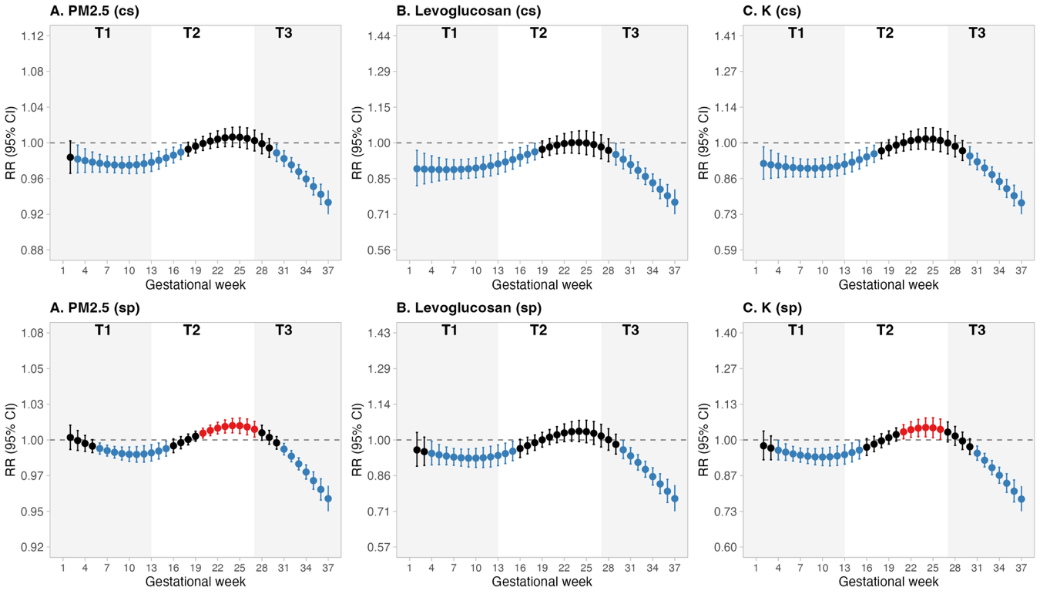
S2. Distributed lag non-linear model of exposure to air pollutants in each week of gestation and risk of congenital heart disease. Linear exposure specification with flexible natural spline lag (df = 4). CS: Temporal method; SP: Temporal spatial method.
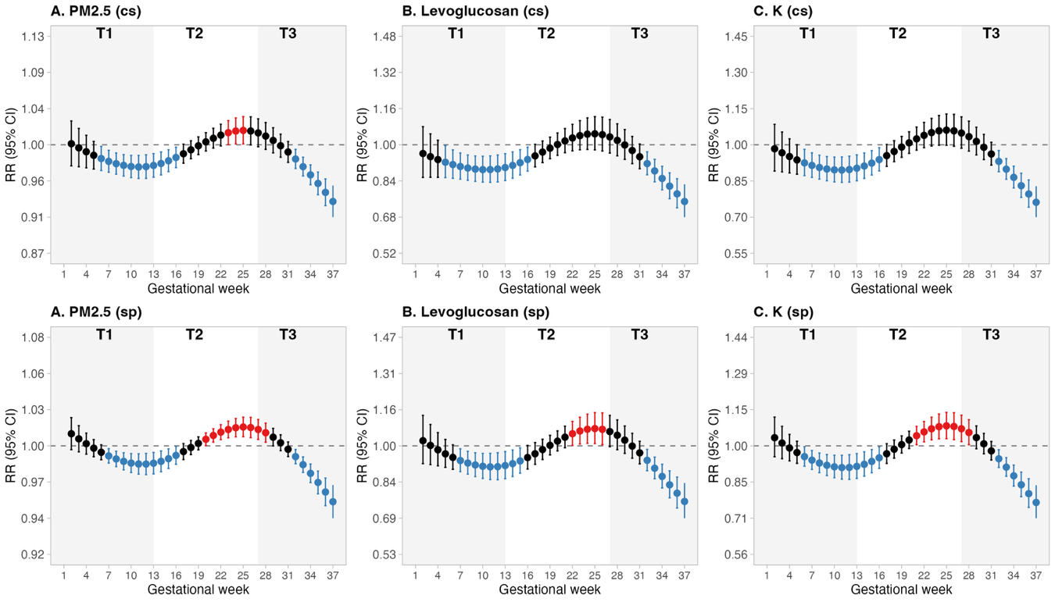

S3. Distributed lag non-linear model of exposure to air pollutants in each week of gestation and risk of congenital malformations. Linear exposure with natural spline lag (knots at weeks 13 and 27). CS: Temporal method; SP: Temporal spatial method.
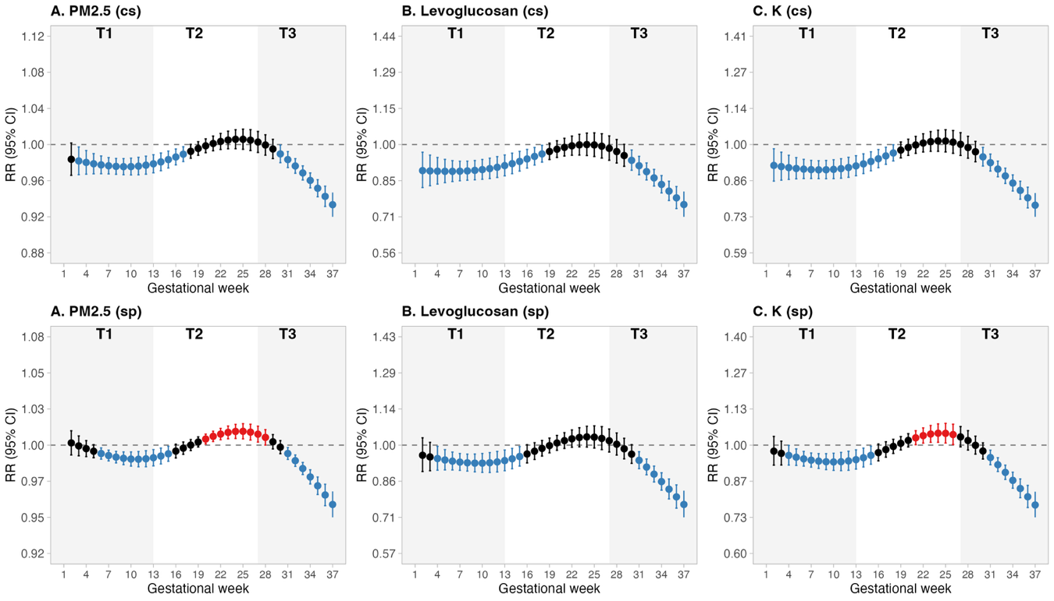
S4. Distributed lag non-linear model of exposure to air pollutants in each week of gestation and risk of congenital heart disease. Linear exposure with natural spline lag (knots at weeks 13 and 27). CS: Temporal method; SP: Temporal spatial method.
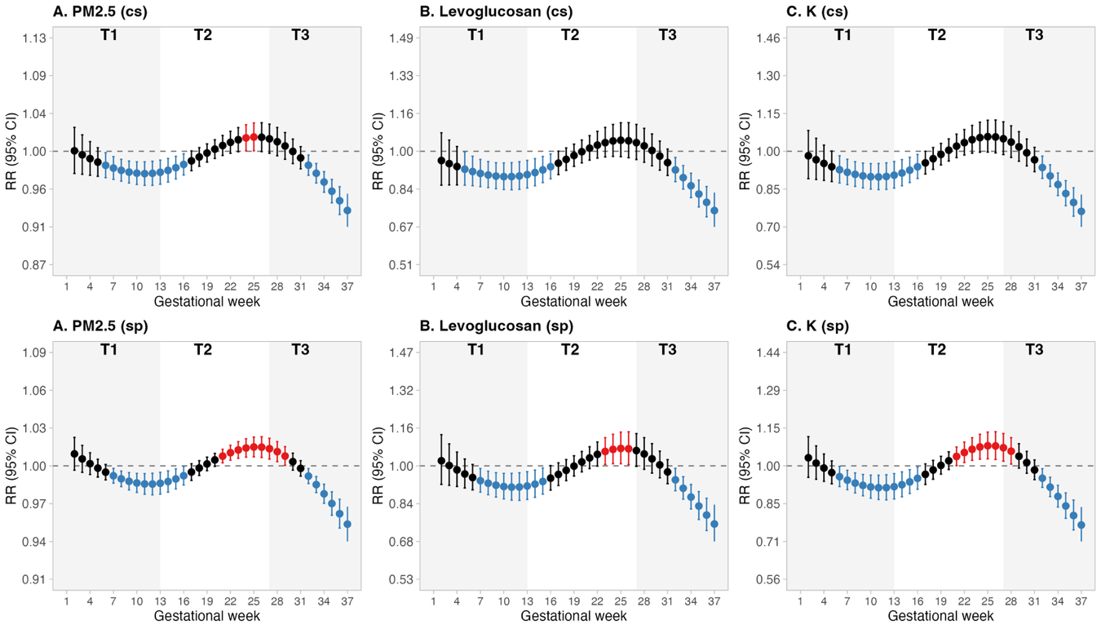

S5. Distributed lag non-linear model of exposure to air pollutants in each week of gestation and risk of congenital malformations. Quadratic B-spline exposure (df = 3) with natural spline lag (knots at weeks 13 and 27). CS: Temporal method; SP: Temporal spatial method.
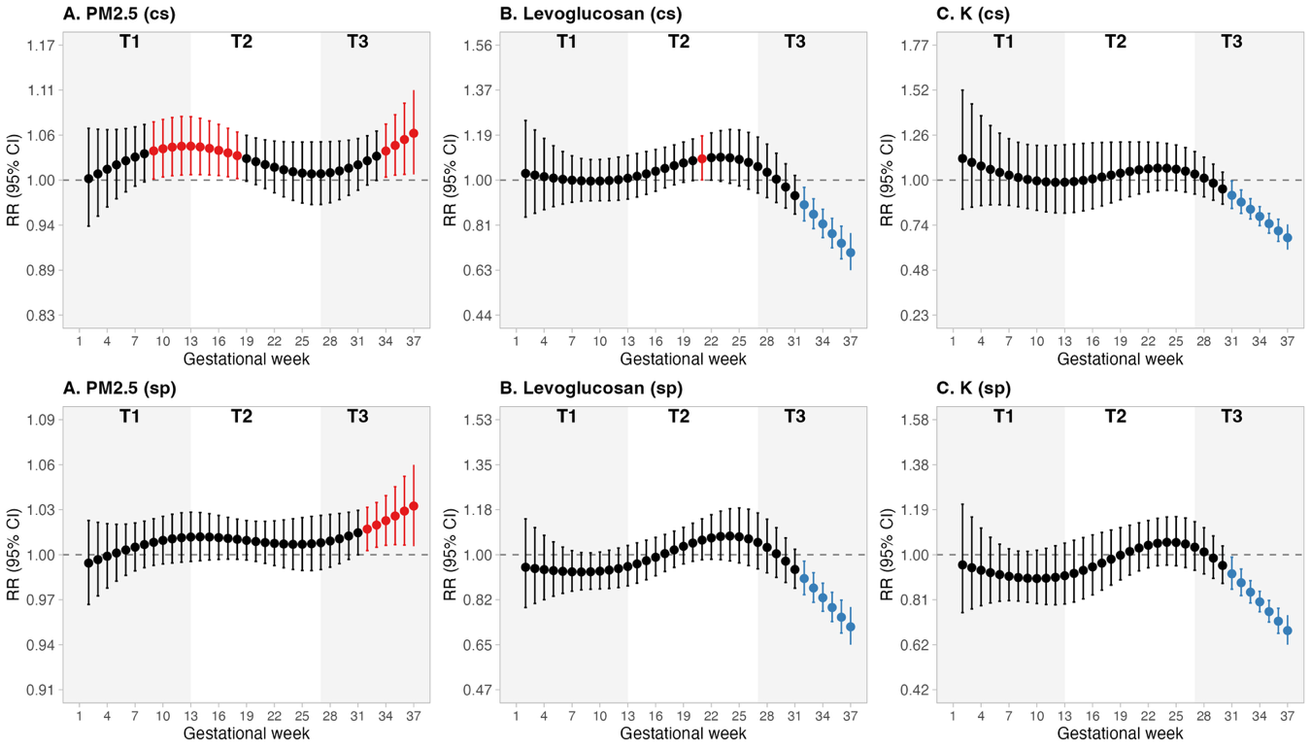
S6. Distributed lag non-linear model of exposure to air pollutants in each week of gestation and risk of congenital heart disease. Quadratic B-spline exposure (df = 3) with natural spline lag (knots at weeks 13 and 27). CS: Temporal method; SP: Temporal spatial method. 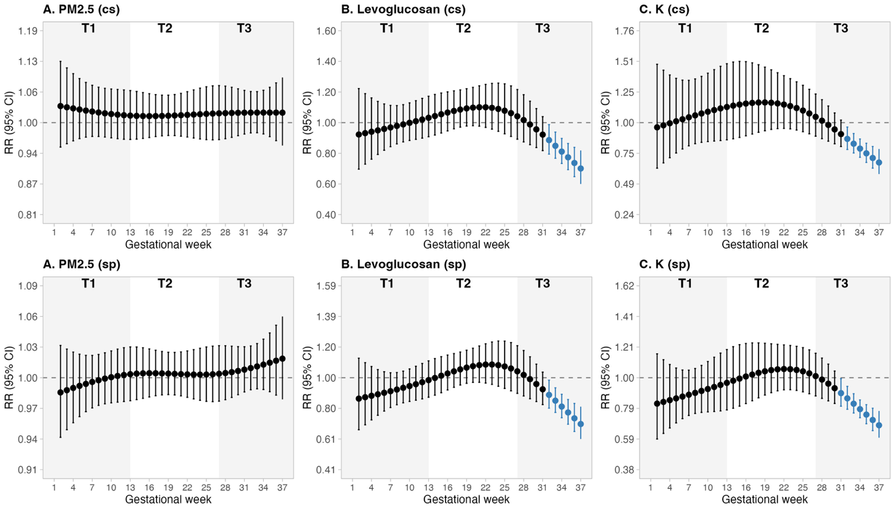

S7. Distributed lag non-linear model of exposure to air pollutants in each week of gestation and risk of congenital malformations. Cubic B-spline exposure (df = 4) with natural spline lag (knots at weeks 13 and 27). CS: Temporal method; SP: Temporal spatial method.
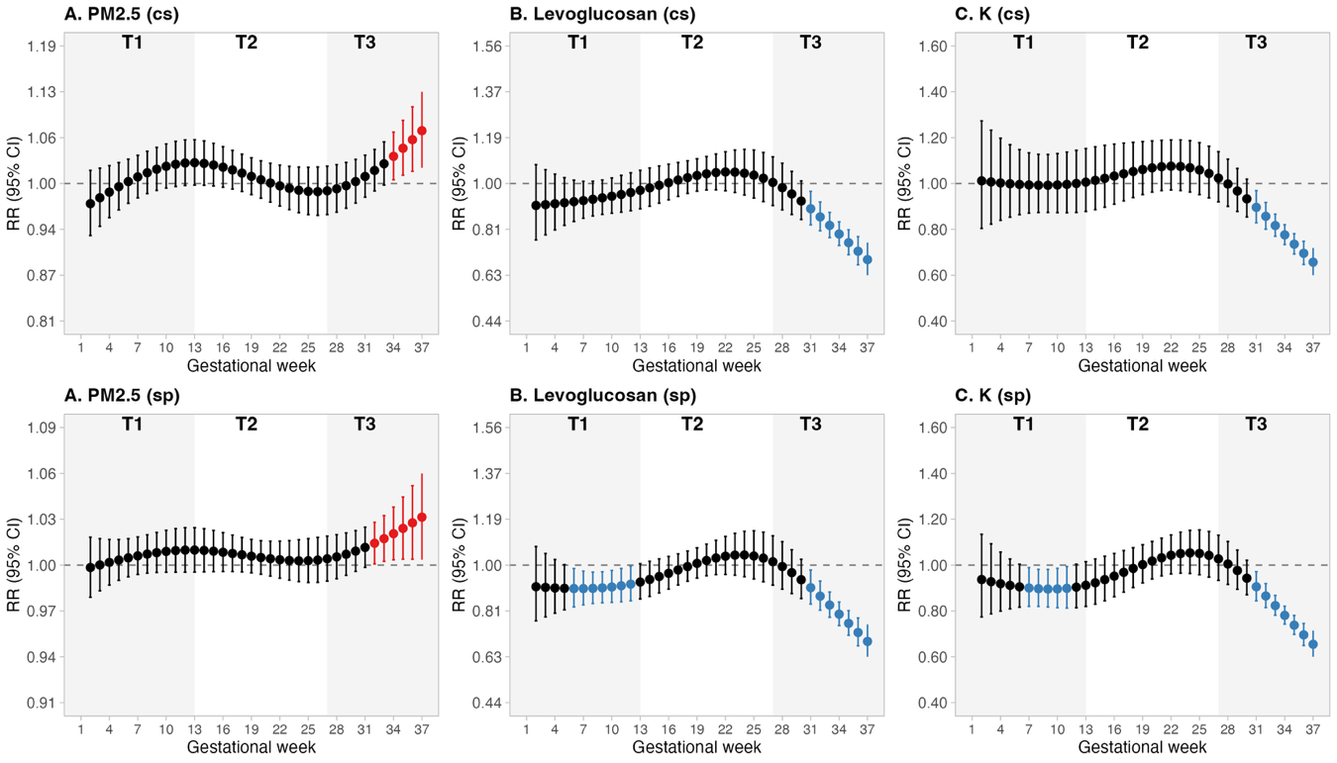S8. Distributed lag non-linear model of exposure to air pollutants in each week of gestation and risk of congenital heart disease. Cubic B-spline exposure (df = 4) with natural spline lag (knots at weeks 13 and 27). CS: Temporal method; SP: Temporal spatial method.
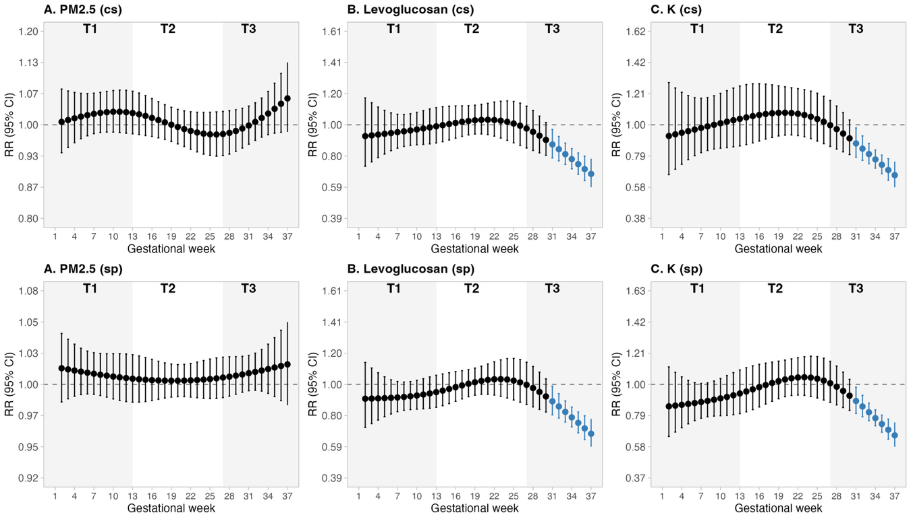

Note figures: All models were adjusted for maternal age, infant sex, year of birth, and season of conception. Relative risks (RR) and 95% confidence intervals (CI) are shown on the scale defined for each pollutant: PM2.5 on the raw concentration scale divided by 10 µg/m³ (reference [cen] = median weekly exposure; comparison [at] = median + 10 units, equivalent to a 100 µg/m³ increase above the median); levoglucosan and potassium on the interquartile-range (IQR) scale (reference [cen] = 0 IQR; comparison [at] = 1 IQR). In supplementary distributed lag non-linear models (DLNM), each point summarizes the RR for that contrast at the indicated gestational week, integrating exposure across lags through the cross-basis; the specific exposure-response and lag structure is given in each panel title. In primary weekly distributed lag models, each point is the RR per unit increase in exposure at that week from a separate logistic model with a weighted sum of prior weekly exposures. In trimester models, each estimate is the RR per unit increase in the corresponding exposure window.

